Melissa Lawrence, CSD 310, Assignment 2.3, 03/30/2024

GitHub link: https://github.com/melkatlaw/csd-310.git

Screen Shot:

ERD:

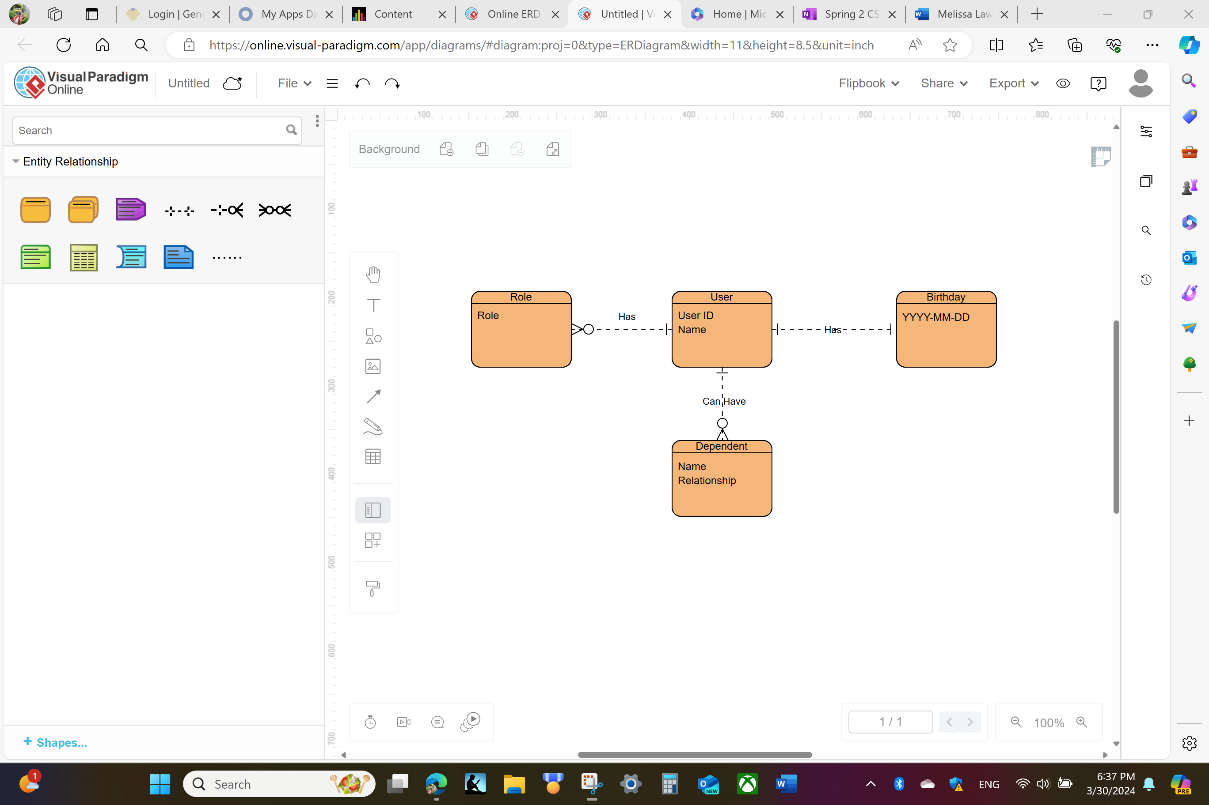

NoSQL Data Structure:

Empty:

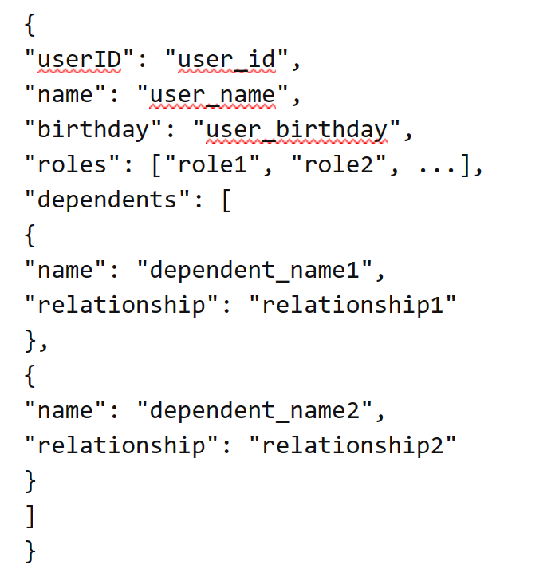

Sample:

